ˆ_JProjectInformation DAAssignment-1

**TeamID:**  LTVIP2025TMID60948

**TeamLeader:**Satya Venkat Musudi

**Teammember:**Sireesha Tandala

**Teammember:**Sneha Deepthi Sri Alluri

**Teammember:**Sri Harsha Kodela

**INSTITUTION: swarnandhra college of engineering and technology**

**ProjectTitle:***MeasuringthePulseofProsperity:AnIndexofEconomicFreedomAnalysis*

⬛#]¡**VisualizationScreenshots**

# ¹⬛BarChart–TotalSalesbyProductLine Caption:

Thisbarchartrepresentsthetotalsalesgeneratedbyeachproductlineacrossallbranches.Itshows that *Food and Beverages*, *Electronic Accessories*, and *Fashion Accessories* are among the top contributors in revenue.

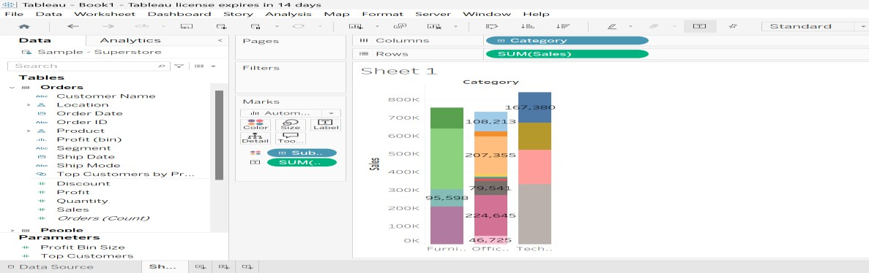

# ⬛2Pie Chart – Payment Method Distribution Caption:

Thispiechartdisplaysthedistributionofcustomerpaymentmethods.Thethreepaymentmethods include *Cash*, *Credit Card*, and *Ewallet*, with

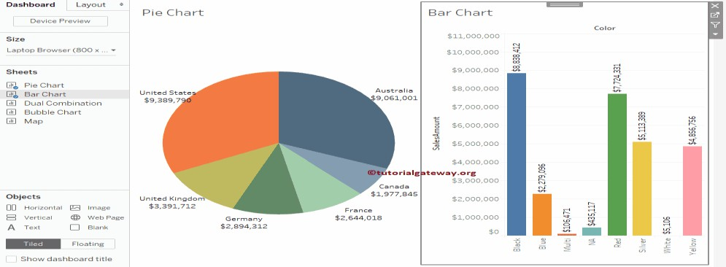

Cashbeingthemostfrequentlyused.

# 3⬛Stacked Bar Chart – Gender-wise Sales across Branches Caption:

This stacked bar chart compares totalsales from maleand female customersin each branch (A, B, andC).Theheightofeachbarshowstotalrevenue,whilethesegmentsshowgendercontribution.

*Insight:*Allbranchesmaintainabalancedcustomerbaseacrossgenders,withslightvariances.

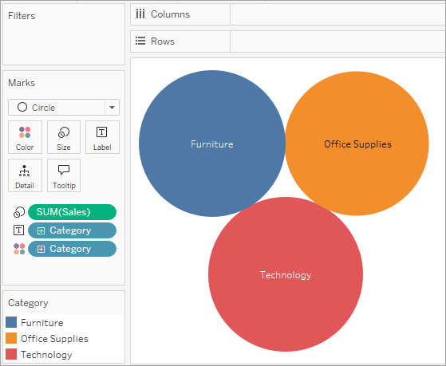

# ⬛f⬛BubbleChart–RatingvsGrossIncome Caption:

Thisbubblechartshowstherelationshipbetweencustomerratingandgrossincome.Bubblesize represents total transaction value, and colors indicate customer types (Member vs Normal).

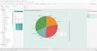*Insight:*Higher-ratedtransactionsareoftenassociatedwithhigherincomeandarelargelyfrom

membercustomers.